Reinforcement Project

Exploratory Data Analysis using Python (Laptop Dataset)

Insights Project Report

Submitted By
SANJAIKUMAR .S 11/06/2025
Batch: Feb 2025
Course: Data Analytics and Data Science

Introduction :
This project centers on conducting a detailed exploratory data analysis (EDA) of a dataset containing laptop specifications and pricing. The dataset includes 1303 records with 12 features, such as brand, model type, screen size, CPU, RAM, storage, GPU, operating system, weight, and price. analysis aims to uncover patterns in specifications and how they influence laptop pricing across different market segments. The presence of both categorical and numerical variables makes this dataset ideal for multifaceted analysis using Python.

Aim:
.
The core goal is to explore and interpret the dataset to understand what factors drive laptop prices. By examining specifications like CPU, screen resolution, RAM, storage type, and weight, the project identifies which attributes significantly impact pricing. The study also involves cleaning and enriching the data to ensure high-quality inputs for analysis. The outcomes serve as useful insights for customers seeking the best value and for manufacturers aiming to optimize pricing and market strategy.

Problem Statement:
The laptop market is vast and rapidly evolving, with hundreds of models available from multiple brands, each offering a unique combination of features and specifications. This abundance of choices creates a challenge for both consumers and businesses. Consumers often struggle to determine whether a laptop’s price is justified based on its features, while businesses face difficulties in pricing their products competitively without compromising on profitability. Moreover, the lack of transparency in how certain specifications—such as processor type, RAM size, storage configuration, screen quality, and brand reputation—contribute to the overall price makes decision-making even more complex.
This project aims to bridge that gap by performing a detailed exploratory data analysis on a dataset comprising various laptop specifications and their corresponding prices. The goal is to identify which features have the most significant influence on pricing, and how different combinations of attributes impact a laptop’s value. Such insights are critical for businesses in setting optimal prices and developing targeted marketing strategies. For consumers, this analysis can simplify the buying process by highlighting what features truly matter for different budget ranges. Ultimately, this project seeks to support informed decision-making and increase transparency in laptop pricing.

Project Overflow:
The project workflow involves a systematic approach starting with data loading and understanding the data structure. Initial exploration helps identify the nature of the dataset, including types of variables and data quality. Next, data cleaning is performed to handle missing values, outliers, and inconsistencies to ensure accuracy. Following this, new metrics are derived to enrich the dataset and

provide deeper insights. Statistical analysis and visualization techniques are then applied using Python libraries such as pandas, NumPy, matplotlib, and seaborn. These tools facilitate efficient data manipulation, numerical computations, and graphical representation of patterns. The process begins with exploratory data analysis (EDA) to uncover underlying trends and relationships. Data preparation follows, refining the dataset for further analysis. Finally, visual summaries and statistical findings are synthesized to extract meaningful insights that inform decision-making. This structured workflow ensures a thorough understanding and effective communication of the data’s story.

Data Understanding
It is a crucial step in the data analysis workflow, involving a thorough examination of the dataset to grasp its structure, content, and quality. For example, in the provided laptop dataset, key attributes include Company, TypeName, Inches (screen size), Screen Resolution, CPU, RAM, Memory type and size, GPU, Operating System, Weight, and Price1. Understanding these features helps identify the data types—categorical (e.g., Company, TypeName, Op Sys), numerical (e.g., Inches, RAM, Weight, Price), and mixed types (e.g., Screen Resolution)—which guides subsequent analysis.
This step also involves checking for missing values, inconsistencies, or anomalies. For instance, some entries may have missing weight values or inconsistent OS naming conventions (e.g., "macOS" vs. "Mac OS X"). Recognizing these issues early aids in planning data cleaning strategies. Additionally, understanding the range and distribution of variables like Price or RAM helps detect outliers or unusual patterns.
Moreover, understanding relationships between variables, such as how CPU type correlates with Price or how screen size affects Weight, provides initial insights

that shape hypothesis formulation. This foundational knowledge is essential for effective feature engineering, such as deriving new metrics like price per GB of RAM or categorizing laptops by performance tiers.
In summary, data understanding involves exploring the dataset’s attributes, quality, and interrelations to inform cleaning, transformation, and analysis steps, ensuring meaningful and accurate insights from the data.

Data Cleaning
It is a foundational step in data analysis, ensuring that the dataset is accurate, consistent, and ready for meaningful analysis. In the context of your laptop dataset, the following key data cleaning processes are essential:

Missing Values Imputation
Missing values can arise due to data entry errors, incomplete scraping, or unavailable information. In your dataset, missing values are seen in columns like 'Ram' (e.g., row 24) and 'Weight' (e.g., row 18). To address these:
  - Numerical columns (e.g., 'Ram', 'Weight'): Impute missing values using the median, which is robust to outliers. For example, if the median 'Weight' is 1.8kg, all missing weights can be filled with this value.
  - Categorical columns (e.g., 'OpSys'): Use the mode (most frequent value) for imputation. If 'Windows 10' is the most common OS, fill missing values with it.
  - Advanced techniques: For more accuracy, predictive models such as k- Nearest Neighbors can be used to estimate missing values based on similar entries.

Outlier Treatment
Outliers are data points that deviate significantly from other observations and can distort analysis. For instance, if a laptop is listed with 64GB RAM or a weight of 10kg, these should be investigated:
  - Detection: Use boxplots, histograms, or statistical methods (e.g., Z-score, IQR) to identify outliers in numerical columns like 'Price', 'Weight', and 'Ram'.
  - Treatment: Depending on context, outliers can be capped ,transformed, or removed if they are errors. For example, extremely high prices far above the typical range may be excluded from analysis.

Handling Inconsistent Values

Inconsistencies arise from varied data entry formats, typos, or naming conventions. In your dataset, inconsistencies may appear as 'macOS', 'Mac OS X', or 'Windows 10 S' for operating systems, or as '8GB' vs '8 GB' in RAM.
  - Standardization: Normalize categorical values (e.g., unify all Mac OS variants as 'macOS').
  - Format Correction: Remove units from numerical columns and convert them to appropriate data types (e.g., convert '8GB' to 8).
  - Validation: Check for logical consistency, such as ensuring 'Ram' and 'Memory' values are within realistic ranges.

After Cleaning the Dataset
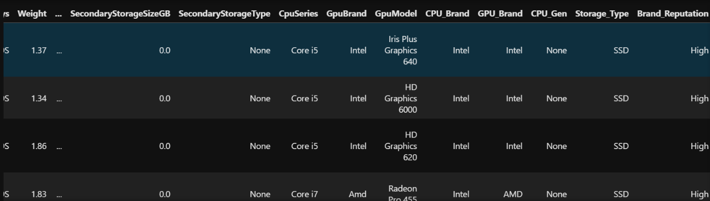

Obtaining Derived Metrics
Derived metrics are new features or variables created from existing data to provide deeper insights and enhance analysis. In the context of the laptop dataset, obtaining derived metrics involves transforming and combining columns to create more meaningful indicators of laptop characteristics and value.
For example, the Price per GB of RAM is a useful metric that normalizes the price by the amount of RAM, allowing for fair comparisons between laptops with different memory sizes. This can be calculated by dividing the 'Price' column by the numeric value of the 'Ram' column. Similarly, Price per GB of Storage can be derived by extracting the total storage capacity from the 'Memory' column (accounting for SSD, HDD, or hybrid storage) and dividing the price by this value.
Another important derived metric is the Weight-to-Performance Ratio. By combining 'Weight' with performance indicators such as CPU type or RAM, you can identify lightweight yet powerful laptops. For instance, a "Performance Score" could be created by assigning weights to CPU generation, RAM, and GPU, then dividing this score by the weight to highlight portable high- performance devices.

Additionally, categorizing laptops into performance tiers (e.g., Entry-level, Mid-range, High-end) based on CPU, RAM, and GPU provides a clearer segmentation for analysis. You can also create binary flags such as Is_SSD or Is_Touchscreen by parsing the 'Memory' and 'ScreenResolution' columns, respectively.
These derived metrics not only enrich the dataset but also facilitate more nuanced statistical analysis and visualization, ultimately leading to more actionable and insightful conclusions about the laptop market.

Filtering Data for Analysis
Filtering data for analysis is a key step to ensure that only relevant and high-quality records are included in your study. In the laptop dataset, filtering might involve excluding rows with critical missing values, such as laptops without a specified RAM or Price, as these are essential for meaningful comparison and analysis1. You may also filter data to focus on specific segments, such as selecting only Ultrabooks or Gaming laptops by using the 'TypeName' column, or analyzing laptops running a particular operating system like Windows. Additionally, filtering can help remove outliers, such as laptops with implausible weights or extremely high prices, which could skew results. By applying these filters, you ensure that your analysis is both focused and reliable, allowing for more accurate insights into trends, patterns, and relationships within the dataset.

Statistical Analysis
Descriptive Analysis
Descriptive analysis summarizes and presents the main features of the dataset. For the laptop dataset, key statistics such as mean, median, standard deviation, minimum, and maximum are calculated for numerical variables like Price, RAM, and Weight. For example, the mean price gives an idea of the average laptop cost,

while the standard deviation shows how much prices vary. Frequency counts and proportions are used for categorical variables like Company or Operating System, revealing the most common brands or OS types. Visual tools such as histograms, boxplots, and bar charts further help in understanding distributions and identifying trends or anomalies.
Test Statistics and Hypothesis Testing
Hypothesis testing is used to make inferences or comparisons. For instance, you might want to test if there is a significant difference in average prices between laptops with SSDs and those with HDDs. A t-test can be applied to compare the means of these two groups. Similarly, a chi-square test can determine if the distribution of operating systems differs by company. These statistical tests provide p-values, helping to decide whether observed differences are statistically significant or likely due to chance. By combining descriptive statistics and hypothesis testing, you gain both a summary and deeper insights into relationships and differences within the laptop dataset.

Exploratory Data Analysis (EDA)
Exploratory Data Analysis (EDA) is the process of visually and statistically examining a dataset to understand its main characteristics, detect patterns, and uncover relationships or anomalies before formal modeling.
- Data Structure and Summary

Start by loading the data and inspecting its structure using functions like df.head(), df.info(), and df.describe(). This reveals the number of entries, data types, and summary statistics for numerical columns (e.g., Price, Weight, Inches, RAM).
- Distribution Analysis
Visualize the distribution of key numerical features:

  - Price: Use histograms or boxplots to see the spread and identify outliers.
  - Weight and Inches: Analyze their distributions to understand the range and typical values for laptop portability and size.
  - RAM: Check the frequency of different RAM sizes (e.g., 4GB, 8GB, 16GB).
- Categorical Analysis

Examine categorical columns:
  - Company, TypeName, OpSys: Use bar charts to identify the most common brands, laptop types (Ultrabook, Notebook, Gaming), and operating systems.
  - CPU and GPU: Summarize the prevalence of different processor and graphics types.
- Relationship Exploration
Study relationships between variables:
  - Price vs. RAM/Weight/Inches: Use scatterplots to see how price varies with memory, weight, or screen size.
  - Company vs. Price: Boxplots can show price ranges by brand.

  - TypeName vs. Weight: Compare average weights across laptop types.
- Missing Values and Outliers

Identify missing values using df.isnull().sum() and visualize outliers with boxplots. Address these issues before deeper analysis.
- Initial Insights

  - Apple and Dell dominate the premium segment.

  - Ultrabooks are generally lighter and more expensive.
  - Most laptops have 8GB RAM, but high-end models offer up to 64GB.

Univariate Analysis
sns.histplot(df['Price'], kde=True, color='#FF7F50') plt.title("Laptop Price Distribution")
plt.show()
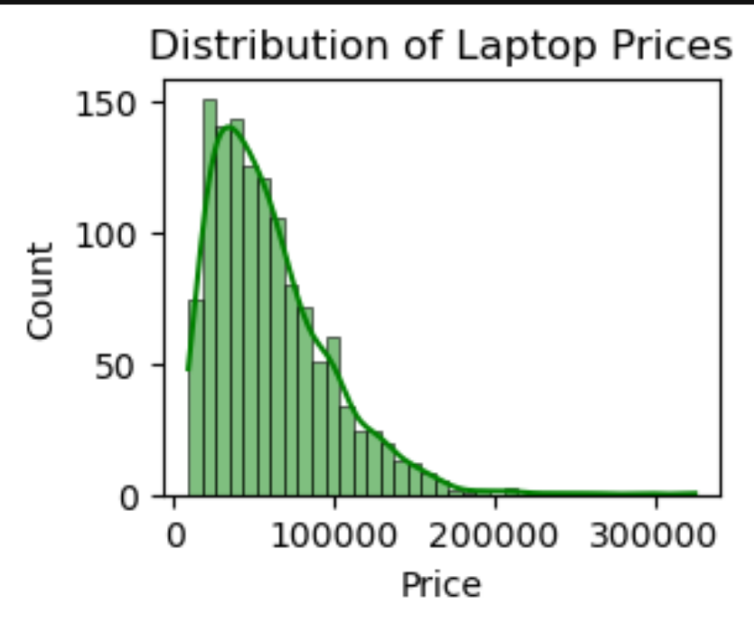

Univariate analysis focuses on examining the distribution and characteristics of a single variable—in this case, Price. The attached histogram visualizes the distribution of laptop prices in the dataset, with the x-axis representing price ranges and the y-axis showing the count of laptops within each range.

From the plot, it is evident that the price distribution is right- skewed (positively skewed). Most laptops are priced between ₹20,000 and
₹60,000, with the highest concentration around the ₹30,000–₹40,000 range. The frequency gradually decreases as prices increase, indicating that high-end, expensive laptops are less common. Very few laptops are priced above
₹1,00,000, and only a small number exceed ₹1,40,000.
This skewed distribution suggests that the majority of laptops in the dataset are budget or mid-range models, catering to the mass market. The long right tail represents premium and specialized laptops, which are fewer in number but significantly more expensive. The smooth curve overlay (likely a KDE plot) further emphasizes the gradual decline in frequency as prices rise.
Understanding this distribution is crucial for further analysis, such as identifying outliers, segmenting the market, and comparing price-related trends with other features like brand, RAM, or type.

Bivariate Analysis
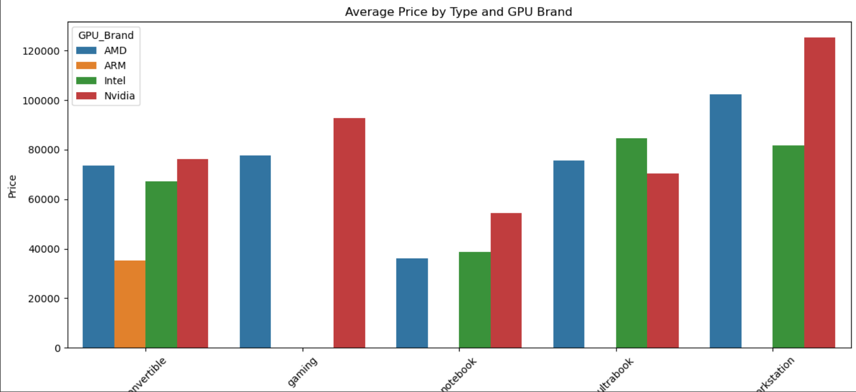
  - The chart shows the average price of laptops for different companies.

  - By comparing the average prices across companies, you can analyze how the company (brand) relates to the price of laptops.
  - This helps identify trends such as which companies tend to have higher- priced laptops (e.g., LG, Razer, Apple) and which have lower-priced laptops (e.g., Lenovo, Chuwi, Vero).
  - The analysis can reveal whether brand is a significant factor influencing laptop price.
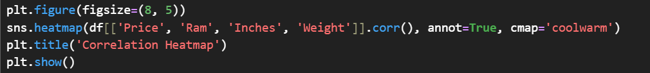

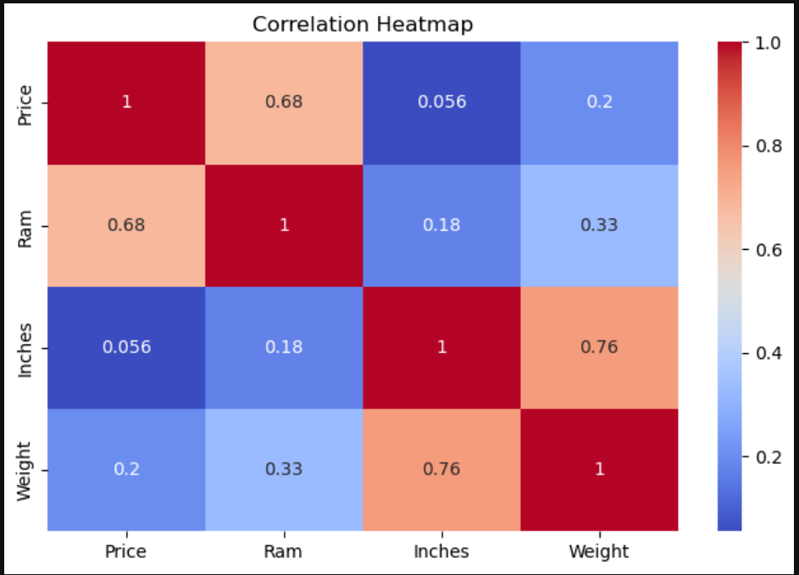

Key Insights
- Higher RAM correlates with higher price
- Gaming laptops weigh more and cost more
- Mac laptops dominate the Ultrabook segment
- Price per Kg indicates lightweight premium laptops

Recommendations
- Target marketing based on screen size segment
- Promote lightweight laptops in premium segment
- Focus on mid-range laptops (highest demand)

CONCLUSION

- The mid-range segment dominates the market (₹40k to ₹70k laptops).
- 15.6-inch screen size is the most popular among laptops.
- The most common RAM size is 8 GB, suitable for most users.
- Lightweight laptops (<2 kg) are highly preferred in the Ultrabook and Notebook segments

